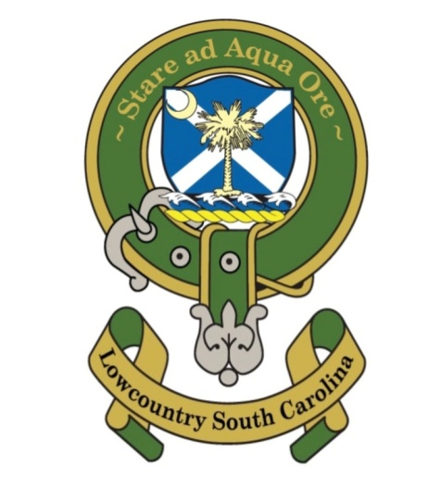
St Andrew’s Society Lowcountry Nov. 30, 2021
Meeting Minutes

The St. Andrew’s Society of Lowcountry South Carolina Annual Member Business Meeting was held on Nov. 30, 2021 6 PM at President Phil Cromer’s home, 162 Spanish Point Drive, Beaufort, SC.
Members present: Phil Cromer, Tom Wilson, Tom Burnett, Wayne Cousar, Jody Henson, Nolan Terrance, James Atkins, Randy Atkins, Frank Gibson, Wilson McElveen, Harold Mills, Graham Walters
President’s Report. President Phil Cromer summarized the Society’s activities of the year and welcomed the members joined since the last Annual Meeting.
Treasurer’s Report: Tom Burnett reported that $2800.65 in the checking account. He said that the Kirkin of the Tartans this month will cost between $1700 and $2000 and that donations to offset the costs are solicited. As part of the Kirkin, $348 was donated to St Helena Church toward the preservation of Old Sheldon Church.
Secretary’s Report: James Atkins had no report as it was his first meeting as Secretary.
Other Reports: None
Old Business: The Robert Burns Dinner was presented by President Cromer as January 22, 2022 at a TBD location, but not Dataw Island Country Club because of its significantly higher cost. A motion to approve was made by Randy Atkins and seconded by Wilson McElveen. The vote to approve was unanimous. President Cromer solicited members to conduct the standard toasts and some members volunteered: To the Office of the President of the United States: Wilson McElveen To Robert the Bruce; James Atkins To Her Brittanic Majesty, Elizabeth I of Scotland; Randy Atkins To Scotland: Tom Burnett To Our Armed Forces: Harold Mills To the Lassies: Nolan Tarrance To the Laddies: TBD To Saint Andrews: TBD To Robert Burns: James Atkins
New Business:
Wayne Cousar moved to increase the annual dues to $125 effective Jan. 1, 2022. The motion was seconded by Tom Burnett. After some discussion, Mr. Cousar amended his motion to increase the annual dues to $150. The motion was seconded by James Atkins. The amended motion passed unanimously.
A Spring Social with spouses and quests was proposed for April 23, 2022 by President Cromer at his home unless some other member desired to host it, which did not occur. Members will be asked to bring food and beverages.
A different location, other than Old Sheldon Church, for the 2022 Kirkin of the Tartans was discussed, with no decision.
President Cromer proposed a Fall Social event with spouses and quests in September or October 2022. No specific date was set.
The 2022 Annual Members Meeting was proposed by President Cromer to be November 30, with the concurrence of the members present.
President Cromer announced that the status of the first Fort Stuart Plaque remains unknown. The Stuart Town seal is, he said, in the possession of the Charleston Library Society and that there is interest in re-casting it and displaying it in the Beaufort Museum.
President Cromer continued that the Stuart Town Action Group, of which he is a member, continues to investigate the physical location of the Town. It may be, he said, on the grounds of the Naval Hospital. He suggested that the Society consider a donation of $2500 to help create a marker that cites Beaufort as the location of the first Scottish settlement in America. The marker might be erected at the Beaufort Waterfront Park, he said.
For future events, President Cromer said he would purchase American and Scottish flags.
There being no further business, a closing prayer was conducted and the meeting was adjourned.
Respectfully submitted:
James P. Atkins Secretary

