St. Andrew’s Society of
Lowcountry South Carolina

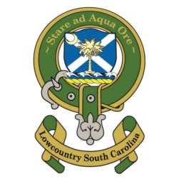
In 2017, a group of gentlemen from the local Sons of the American Revolution Chapter in Beaufort SC formed “St Andrew’s Society of Lowcountry South Carolina”. This Scottish Heritage group from the SAR Chapter had completed an expedition to the mother land – Scotland and thought they should form a local St Andrew’s Society. The original Directors – Carroll Crowther, Wayne Cousar, and Joe Harden, had their first official meeting with other Founding Members on January 19, 2017.

Welcome to our 5th Annual
Kirkin’ o’ the Tartan - Worship Service

A Service of Worship
& Kirkin’-o’-the-Tartan

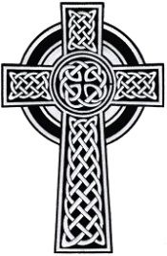
November 18, 2023 – 12 noon
Old Sheldon Church

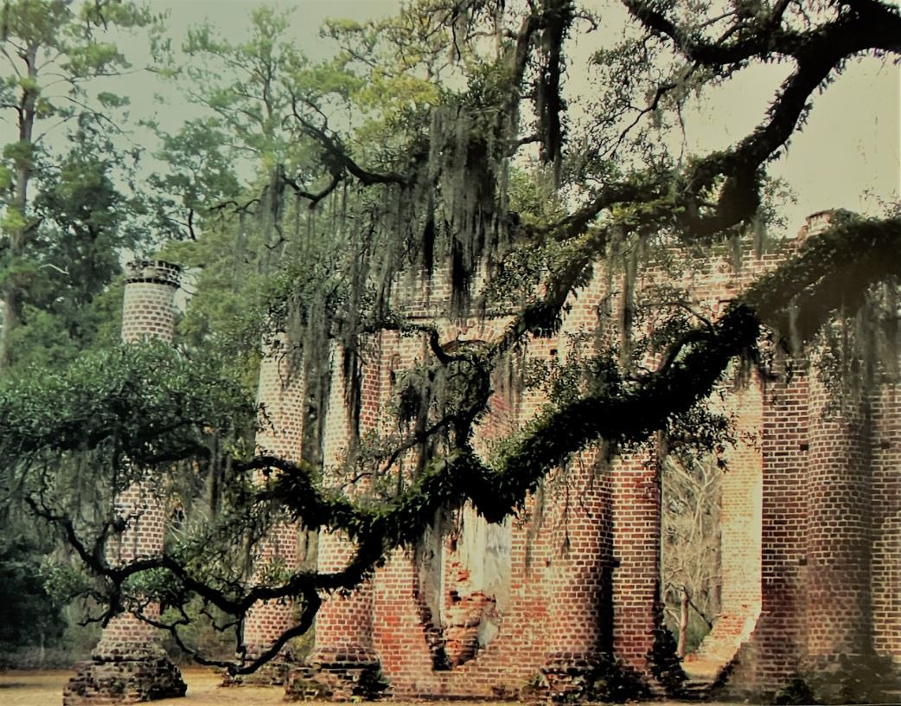

A Service of Worship
& Kirkin’-o’-the-Tartan
November 18, 2023
12 noon
Old Sheldon Church

Striking of the Hour
Processional - All Stand Highland Cathedral
Grace be unto you and peace from God our Father and the
Lord Jesus Christ.

Invocation and Call to Worship:
(Pastor Steve Keeler – Sea Island Presbyterian)
Venite, exultermus Domini (In unison)
O come let us sing unto the LORD; let us heartily rejoice in the strength of our salvation.
Let us come before His presence with thanksgiving; and show ourselves glad in Him with psalms.
For the LORD is a great God; and a great King above all gods. In His hand are all the corners of the earth; and the strength of the hills is His also.
The sea is His, and He made it; and His hands prepared the dry land.
O come, let us worship and fall down, and kneel before the LORD our Maker.
For He is the Lord our God; and we are the people of his pasture, and the sheep of His hand.
O worship the LORD in the beauty of holiness; let the whole earth stand in awe of Him.
For He cometh, for He cometh to judge the earth; and with righteousness to judge the world, and the people with His truth.

1
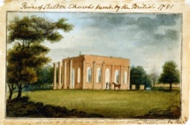
Sheldon Church
Prince William’s Parish

Established in 1745, Sheldon church was built between 1751 and 1756 on land donated primarily by the Bull family and named after their ancestral home in Warwickshire, England. Described as a monument to Anglican wealth and spiritual primary, the church was designed as a compact auditory; built along a row of seven classic columns with colonnaded walls three-and-a-half feet thick. It was the earliest example of classical Greek architecture in America.

With reports that arms and munitions were hidden at Sheldon Church, British troops, under the command of General Augustine Provost, burned the church in May 1779 during the American Revolution.

Sheldon lay in ruins until 1825 when a Vestry was formed to restore the church to the center of spiritual life in Prince William’s Parish. It prospered during the remainder of the antebellum era as a parish of the Protestant Episcopal Diocese of South Carolina, but it would not survive the American Civil War.

During the Civil War (1861-1865), abandoned slaves on nearby plantations stripped the church of its timbers and furnishings for materials to build shelter. The church would never again be restored, and over time the ruins became known as Old Sheldon Church, Prince William’s Parish.

In 1925, the Parish Church of St. Helena reclaimed these ruins from the encroaching wilderness and has scheduled an annual service at this site as a continuing legacy of Old Sheldon’s spiritual heritage.

The Protestant Episcopal Diocese of South Carolina transferred ownership of Old Sheldon to St. Helena’s Church in 1971. The ruins have become an iconic image in South Carolina history and are listed on the National Register of Historic Places.
Protecting the Ruins

- For your safety and the preservation of this sacred site, please do not climb or stand on any gravestones or any part of the ruins.
- For the preservation of the bricks, only enter and exit the ruins through the front entrance by the columns. Do not use the windows as a doorway.
- Please treat the inside of the ruins with the reverence you would have for the inside of your own church.
- Around the ruins, graves, and the road, children should be supervised at all times for their safety.
Invitation to Confession (Pastor Keeler)
(Congregation Seated)
Let us humbly confess our sins unto Almighty God

A General Confession (In unison) (Pastor Keeler)

Almighty and most merciful Father, we have erred, and strayed from Thy ways like lost sheep: We have followed too much the devices and desires of our own hearts. We have offended against Thy holy laws. We have left undone those things we ought not to have done; And have done those things which we ought not to have done; And there is no health in us. But thou, O Lord, have mercy upon us miserable offenders. Spare thou those, O God, who confess their faults. Restore those who are penitent; According to Thy promises declared unto mankind In Christ Jesus our Lord. And grant, O merciful Father, for His sake; That we may hereafter live a godly, righteous, and sober life, To the glory of the holy name. Amen.

Assurance of Pardon (Pastor Keeler)
Almighty God, the Father of our Lord Jesus Christ, who desired not the death of a sinner, but rather that he may turn from his wickedness and live, hath given power, and commandment, to his Ministers, to declare and pronounce to His people, being penitent the Absolution and Remission of their sins. He pardoneth and absolveth all those who truly repent, and unfeignedly believe His holy Gospel.

Wherefore let us beseech Him to grant us true repentance, and His Holy Spirit, that those things may please Him which we do at this present; and that the rest of our life hereafter may be pure and holy; so that at the last we may come to his eternal joy; through Jesus Christ our Lord. Amen.
3
The Lord’s Prayer (In unison) (Pastor Keeler)
Our Father, who art in heaven, Hollowed be Thy Name. Thy kingdom come. Thy will be done on earth, As it is in heaven. Give us our daily bread. And forgive us our trespasses, As we forgive those who trespass against us. And lead us not into temptation; But deliver us from evil; For thine is the kingdom, and the power, and the glory, for ever and ever. Amen.

The Apostles Creed (In unison) (Pastor Keeler)
I believe in the God the Father Almighty, Maker of heaven and earth: And in Jesus Christ his only Son our Lord: Who was conceived by the Holy Ghost, born of the Virgin Mary: suffered under Pontius Pilate, Was crucified, dead, and buried: He descended into hell; The third day He rose again from the dead: He ascended into heaven, And sitteth on the right hand of God the Father Almighty: From thence He shall come to judge he quick and the dead. I believe in the Holy Ghost: The holy catholic Church; The Communion of Saints; The Forgiveness of sins; The Resurrection of the body; And the Life everlasting. Amen.

Offertory Amazing Grace ……………………..PIPERS

4
Scripture Reading: (Pastor Keeler)

Homily: (Pastor Keeler)

--------------------------------------------------------------------

HISTORY: “HOW THE SCOTS-IRISH SHAPED AMERICA”
Presenter - (Col Harold Mills)

Kirkin’ o’ the Tartans (Congregation Stand)
Presenter: On behalf of all the Clans represented here, we raise these Tartans before Almighty God in gratitude for our heritage and pray God’s Blessing on his servant people in all lands.
Pastor Keeler: Eternal God our Father, bless these symbols of our heritage and grant that those who wear them and the families they represent may do justly, love mercy and walk humbly with Thee, through the grace of Jesus Christ, our Lord. Amen.

---------------------------------------------------------------------

Prayer for our Nation: (Pastor Keeler)

Benediction and Dismissal:(BISHOP ALDEN HATHAWAY)

The Lord bless you and keep you. The Lord make His face to shine upon you. The Lord lift up the light of His countenance upon you and give you His peace this day and always.

Recessional: Scotland the Brave……………PIPERS

5
Hymn: My Country ‘Tis of Thee (Congregation Stand)

My country, ‘tis of thee,
Sweet Land of liberty,
Of thee I sing;
Land where my fathers died,
Land of the pilgrims’ pride,
From every mountainside
Let freedom ring!

My native country, thee,
Land of the noble free,
Thy name I love;
I love thy rocks and rills,
Thy woods and templed hills;
My heart with rapture thrills,
Like that above.

Let music swell the breeze,
And ring from all the trees
Sweet freedom’s song;
Let mortal tongues awake;
Let all that breathe partake;
Let rocks their silence break,
The sound prolong.

Our fathers’ God, to Thee,
Author of liberty,
To Thee we sing;
Long may our land be bright
With freedom’s holy light;
Protect us by Thy might,
Great God, our King.

2

