St. Andrew’s Society

Lowcountry South Carolina

Beaufort, South Carolina
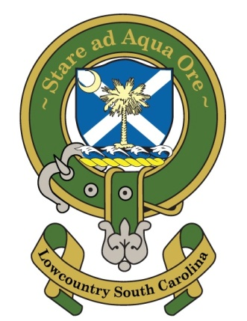
Minutes from the First Quarter 2020
Saint Andrews Society of Lowcountry SC,3 April 2020
The First Quarter 2020 Board of Directors meeting was held via email on this date. Participating in the email meeting at the time or in follow up emails or phone calls, were Tom Wilson, Carroll Crowther, Tom Burnet, Phil Cromer, Joe Harden, Joe Riddle, Matt St. Clair, Mark Henderson, and Wayne Cousar.

1. Several changes to the By Laws were approved by the Board. The revised Bylaws will be sent to full membership for a vote.
A Discussion was held as to how long an invitation to a new member should be held open. While there was a wide difference in opinion, the ideal number appears to fall between 30 and sixty minutes. So 45 days will be the proposed by laws change when those changes are sent to the membership.
2. Joe Riddle is putting together a printed roster for the Society, and Board members were asked to make sure that Joe had all the information he needed for each Board member.
3. Wayne is working on another Kirkin of the Tartans service, and more information will be provided when available.
4. Exchequer reports that we are sound financially and books and statements are available for all to see.
5. After discussion, there was general agreement that membership should be limited to something between 30 and 50, and that annual dues should be increased to $100. It was agreed that this was not something we had to be decided at this email meeting, so further discussion and decisions on dues and membership numbers will be taken up at future meetings.
6. a. The upcoming election of New Officers and directors at the upcoming November business meeting was discussed. New Officers will be elected at our 3rd annual Business meeting in November( time and place to be determined) and will take over their respective offices on January 1, 2021. In the meantime, membership will be alerted to the several opportunities for service that will be available, and volunteerism encouraged. Potential candidates for each available slot should be identified by the Board by the end of October.
6. As an expression of appreciation for their roll work in the origination of the Society, the Board voted to create the position of “Founding Directors” for Wayne Cousar, Carroll Crowther, and Joe Harden. They will serve as the “Founding Directors” and members of the Board for as long as they wish. They will be designated as such in the yet to be completed membership roster. Those other Society members who were at the original Dec. 2016 meeting will be designated in the yet to be completed membership roster as “Founding Members”
7. It was decided by the Board that The Society would not provide the Citadel with another set of pipes until the financial reserves of The Society are more robust. Society members either as individuals or a group may want to take up that project.
There being no further business, the first quarter 2020 Email meeting was concluded.
Tom Wilson, President

