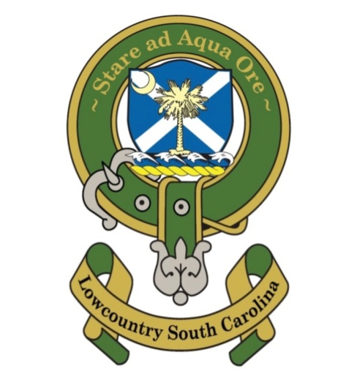
St Andrew’s Society Lowcountry South Carolina
Annual Business Meeting – Oct 30,2020
Meeting Minutes

The St Andrew’s Society Lowcountry South Carolina Annual Member Business Meeting was held on Oct 30, 2020 from 6 to 8 pm at Phil Cromer’s home at 162 Spanish Point Driver, Beaufort SC 29902. President Wilson thanked the Cromers for their hospitality and allowing us to meet at their home back patio.
Quorum - A quorum (50% or greater) was established by 20 (18+2) of 29 current members.
In attendance were 18:
Phil Cromer, Tom Wilson, Joe Riddle, Tom Burnett, Carol Crowther, Wayne Cousar, Tom Moody, Hastings Greene, Bill Sammons, Mike Monahan, Jody Henson, Tommy Logan, Nolan Terrance, Jim Atkins, Randy Atkins, Frank Gibson, Wilson McIntosh, Jon Simpson
Proxies were 2:
Matt St Clair, Craig Bowman
Discussion Topics:
- Robert Burns Dinner Jan 23, 2021 – Monahan discussed issues with Dataw Country Club that SAR was having and recommended that we have the RBD at Marine Air Station Officers Club. All agreed to have the dinner move to alternate location and maybe alternate date. The majority Voted in favor of having the RBD.
- 2021-2022 Officers Election – Secretary Riddle lead the elections – Open seats were President, Vice President, Secretary, Exchequer, & 1 Director at Large. After the floor was open for nominations: Nominations were Phil Cromer for President, Joe Riddle for Vice President, Jim Atkins for Secretary, Tom Burnett for Exchequer, Randy Atkins for Director at Large. A Vote was held and all Nominations were approved unanimously *including Proxies. The new Officers will assume their positions on January 1, 2021.
- SASLSC Bank Account – President Wilson discussed the need for the Society to have a checking account. The Vote was unanimous to establish a bank account at 1st Federal Bank and get a tax number if needed in order to establish the account.
- Society Due increase – President Wilson discussed that the Board of Directors had recommended that the annual dues be increased to $100 per year. A Vote was taken and the Annual Dues of $100/year motion was approved. President Wilson reminded those present that Dues are due on or before Dec 31st of each year.
- Stuart Town Marker – Director at Large Phil Cromer discussed that the Society is looking to find the Plaque/Marker that use to be at the old bank corner of an alley and Bay Street just before the bridge. It was recommended that a Committee be formed and report back to the Board of Directors with a recommendation (marker found or not, go halves with Beaufort County Historical Society on a new marker, new location of marker, etc). Additionally, the Committee is to look into “The Stuart Town Seal” that is located at The Charleston Museum. The Committee is made up of Cromer, Henson, Logan, Riddle.
- Kirkin-o-the-Tartans (Nov 14, 2020. 12 noon) - Wayne Cousar discussed the details of the Kirkin and was looking for help and sponsorship. Wayne asked that everyone be on site by 11am and the service starts at 12 noon. The Theme is American Patriotism. 1st Scots Alex Mark will be the Minister; Alden Hathaway will give a prayer. Sponsorship for the Band, Police and Porta Potties were covered. The same Pipe & Drum Band as last year will be used.
Assignments were:
Bulletin – Riddle, Wilson, Moody Printing & Sponsorship
Parking decided for people to park on their own.
Physically moving Poles and Stands – Gibson, Cromer
Bring Chairs – Moody
Pictures – Greene
Ushers – Greene, Sammons
Signs – Terrance

Respectfully submitted,
Joe Riddle
Secretary
St Andrew’s Society Lowcountry South Carolina

